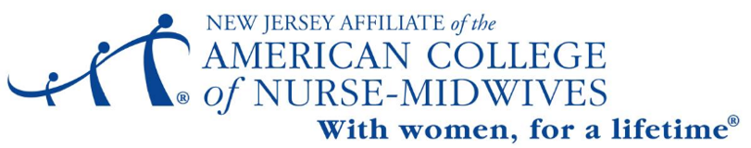

Student and New Midwife Award

The NJ Affiliate of the American College of Nurse Midwives Student/New Midwife Award is designed to support a student currently enrolled in the last year of a midwifery program or a new graduate midwife. The recipient will receive one year of national and NJ Affiliate ACNM membership dues ($314. value).

Eligible Applicants:
- Current enrollment in the last year of an ACME-accredited midwifery education program in good standing or graduation within the last year
- Commitment to join one affiliate committee and attend at least 50% of affiliate activities, events or meetings during their first year as a midwife (second year in the case of new graduates)

Please complete both the below application and essay by September 26, 2021.
Applicant data:
Name, Current Address, ACNM membership # (if already an ACNM member)

Current Students:
Midwifery education program & Expected/Graduation date
Graduate Midwives:
Midwifery education program & Graduation date

Personal Statement:
Please submit a short statement (200 words max) or short video answering the following:
- What are your future plans as a midwife?
- What is your intended future participation in ACNM activities at a local and/or national level?

I hereby certify that the information above is accurate and complete.

Applicant signature
Date
Current Contact: Your Phone & Email

Page 1 of 2
NJ ACNM Affiliate Student Midwife Award 2021

Please, submit this application form and attached documents to both
Metta Cahill CNM MSN, Co-Chair, Student Liaison Committee, mettacnm1@aol.com
Jasmine McCracken BSN RN, Co-Chair, Student Liaison Committee jasminemccracken01@frontier.edu

Recipients of this award will be announced in October of 2021.

Page 2 of 2

Rev 9/2021 DD

